Vincent Ryan

6/21/2024

Module 4 – My SQL Setup

Initial Connection:

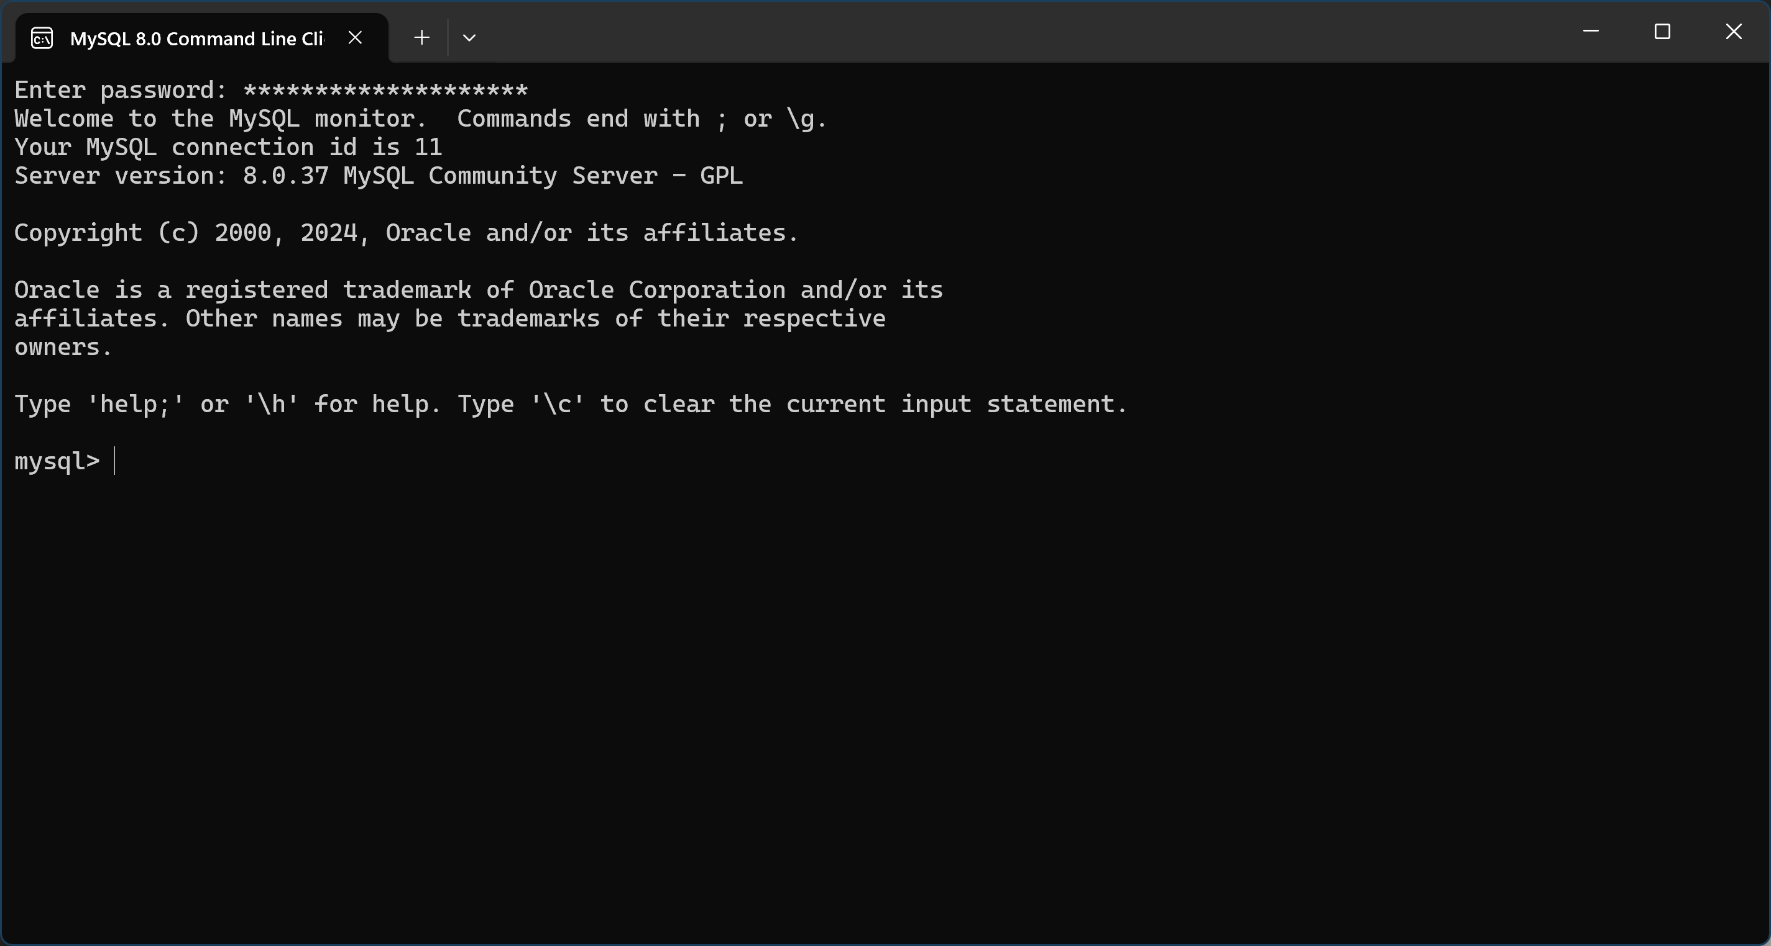

Created Movies Database:

You can see I struggled with the syntax a little. I hadn’t quite picked up that you need to include the ; because many commands in SQL are multi-line. I also didn’t understand whether I was supposed to put the word movies in quotes, single quotes, or less-than greater-than signs as written in the example. Eventually I figured it out and voila a movies database.

